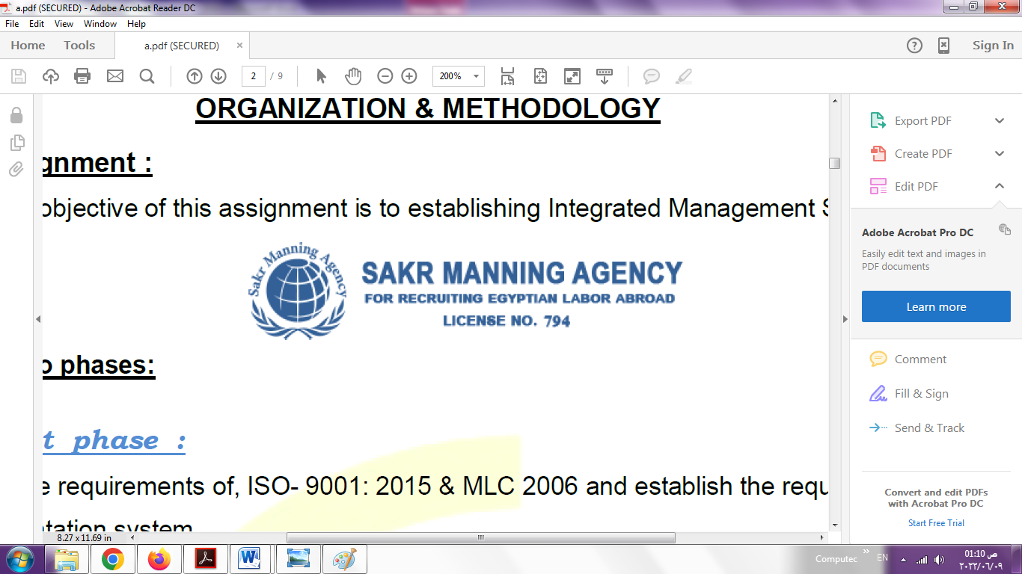 | SAKR MANNING AGENCY  FOR RECRUITING EGYPTIAN LABOR ABROAD | Issue Date | 15.05.2022
 |  | Revision Date | 01.02.2024
 | Crewing Management Manual  Seafarer Employment Application | Revision | 1.3
 |  | Page | 4

Application For Position as | ABLE SEAFARER ENGINE
Register Code. | ER-3.191
Other Position (If Any) | ASSISTANT AC
Register Date | 10/11/2024
Last up Date Data
Expected Salary / Available Date | 1500$


1. PERSONAL DETAILS
Full Name | AHMED MOHAMED MOSAAD MOHAMED
Date Of Birth | 24/1/1995 |  |  |  |  |  | Marital Status |  |  |  |  | Single ☐ |  |  |  |  |  | Married ✅
Nationality | EGYPTIAN |  |  |  |  |  | Height (Cm) |  |  |  |  | 175 CM |  |  |  |  | Weight (Kg) |  |  |  |  | 75 Kg
Place Of Birth | SHARKIA |  |  |  |  |  | Overall Size |  |  |  |  | XL |  |  |  |  | Shirt Size |  |  |  |  | XL
Nearest Port | Damietta |  |  |  |  |  | Trouser Size |  |  |  |  | 33 |  |  |  |  | Shoes Size |  |  |  |  | 42EU  10.25 inch  26 cm
2. EDUCATION
College / School | Technical Institute For Maritime Installation in Port Said 2016 .
Marline Test | Issued Date |  |  |  | Result % |  |  | Issued By (Authority) |  |  |  |  |  |  |  | Issued At
English Language | Fluent ☐ |  |  |  |  | Good ✅ |  |  |  |  | Average ☐ |  |  |  |  | Poor ☐
……… Language  ( Greek) | Fluent ☐ |  |  |  |  | Good ☐ |  |  |  |  | Average ☐ |  |  |  |  | Poor ✅
3. CONTACT DETAILS
Home Address / City | Hosni hammad street . Mahmoud shaheen street mansoura dakahlia Egypt
E-Mail | AMEDOO115@GMAIL.COOM |  |  |  |  |  | Mobile / Tel |  |  |  |  |  | 01013186104 |  |  |  |  |  | 01026658929

4. TRAVEL DOCUMENTS
Type | Document No. |  |  | ISS. Date |  |  | Exp. Date |  |  | ISS. By (Authority) |  |  |  |  |  |  |  | Place of Issue
Passport | A24507062 |  |  | 13/3/2013 |  |  | 17/3/2026 |  |  | Egyptian Authority |  |  |  |  |  |  |  | 22
Seaman Book | S00028648 |  |  | 7/2/2023 |  |  | 4/2/2028 |  |  | EAMS |  |  |  |  |  |  |  | Alex.
Other Seaman Book | Cy 312029 |  |  | 9/1/2020 |  |  | 8/1/2030 |  |  | cyp |  |  |  |  |  |  |  | Limassol

5. PROFESSIONAL QUALIFICATION / CERTIFICATE OF COMPETENCY
Certificate Name |  |  | Number | Issue Date |  |  |  |  | Expiry Date |  |  |  |  | Issued By |  |  |  |  |  |  | Issued At
COC ( Rank) ………….. |  |  |  |  |  |  |  |  |  |  |  |  |  | EAMS |  |  |  |  |  |  | Alex.
GOC |  |  |  |  |  |  |  |  |  |  |  |  |  | NTRA |  |  |  |  |  |  | Cairo
6. NEXT OF KIN / EMERGENCY CONTACT
Full Name |  | AYA HESHAM AHMED |  |  |  |  | Relationship |  |  |  | MY WIFE
Address / Country |  | Hosni hammad street . Mahmoud shaheen street mansoura dakahlia Egypt
Tel. No./ Mobile |  | 01026658929 |  |  |  |  | Email |  |  |  | Ayaaat2017elshikh@gmail.coom
7. HEALTH CERTIFICATES & VACCINATIONS
Flag State |  | Number |  |  | Issue Date |  |  |  | Expiry Date |  |  |  |  |  | Issued By |  |  |  |  | Issued At
International Medical |  | 26724 |  |  | 26/3/2024 |  |  |  | 25/3/2026 |  |  |  |  |  | EAMS |  |  |  |  | Alex.
Yellow Fever |  |  |  |  | 26/2/2019 |  |  |  | forever |  |  |  |  |  | Ministry of Health
Cholera |  |  |  |  |  |  |  |  |  |  |  |  |  |  | Ministry of Health |  |  |  |  | Cyp
Covid-19 |  | Vaccination Name |  |  | First Dose |  |  |  | Second Dose |  |  |  |  |  | (Other Does or Remarks)
 |  | Janssen-cilag International |  |  | 18/6/2021

8. MARINE COURSES
Course Name | Number | Issue Date | Expiry Date | Issued By / At
Personal Survival Techniques | XBST1667 | 28/3/2024 | 4/3/2029 | EAMS / Alex
Proficiency In Personal Survival Techniques
Fire Prevention and Fire Fighting | XBST1667 | 28/3/2024 | 4/3/2029 | EAMS / Alex
Advanced Fire Prevention and Fire Fighting
Elementary First Aid | XBST1667 | 28/3/2024 | 4/3/2029 | EAMS / Alex
Medical Care Studies | 26724 | 26/3/2024 | 25/3/2026 | EAMS / Alex
Personal Safety and Social Responsibilities | XBST1667 | 28/3/2024 | 4/3/2029 | EAMS / Alex
Proficiency Of Security Awareness Training Seafarers | XNA6956 | 25/3/2024 | 6/3/2029 | EAMS / Alex
Proficiency as a ship Security officer ( PSSO ) | ------
Proficiency In Survival Craft & Rescue Boats | XNC3973 | 28/3/2024 | 6/3/2029 | EAMS / Alex
G.M.D.S.S | -------
Communications | --------
Advanced Communications | --------
ECDIS Advanced Simulator (Management Level) | --------
ECDIS Simulator (Operation Level) | -------
Prevention and Combating of Marine Pollution | -------
Radar & ARPA Simulator and Search &rescue  ARPA Simulator and Search | --------
Marine Radar and automatic Radar Plotting | --------
Bridge resource Management (B.R.M) | ---------
Engine resource Management (E.R.M) | -------
Navigational Watch keeping | -------
Proficiency for Rating forming part of Navigational watch (II/4) | -------- |  |  | EAMS / Alex.
High voltage training – operation of ship (1000 Volt and More) | -------
Passenger Safety Cargo Safety and Hull integrity | 14760/19/EG | 14/4/2019 | 3/4/2024 | EAMS / Alex
Crowd Management Training | 14714/19/EG | 14/4/2019 | 30/3/2024 | EAMS / Alex
Crisis Management and Human Behavior Training | 14737/19/EG | 14/4/2019 | 2/4/2024 | EAMS / Alex
Safety training for Personal Prov. Direct Passengers | 14691/19/EG | 14/4/2019 | 1/4/2024 | EAMS / Alex
Practical Ability to Prepare Meals and (MLC 2006) | ---------
Personal Hygiene and Envir. Protection (MLC 2006) | --------
Safety and Health in the Provision Meals (MLC 2006) | ---------
Food Storage and inventory Control (MLC 2006) | --------
Ships Cook Certificate (MLC 2006) | -------- |  |  | EAMS / Alex.
Abel Seafarer Deck | -------
Proficiency for Abel Seafarer Deck ( II/5 ) | -------- |  |  | EAMS / Alex.
Engineering Watch keeping | 15740/21/EG | 5/5/2021 |  | EAMS / Alex.
Proficiency for Rating forming part of a watch in engine room | ---------
Abel Seafarer Engine | 31659/22/EG | 20/10/2022
Proficiency for Abel Seafarer Engine ( III/5 ) | 00369 | 14/2/2023 |  | EAMS / Alex.
Electro Technical Rating | --------
Proficiency for Electro Technical rating ( III/7 ) | ------- |  |  | EAMS / Alex.
D.p. induction/ d.p. advanced | --------
D.p. operator (unlimited) | -------
Others

 |  | 9 - COMPLETE SEA – SERVICE DETAILS
Name: |  | AHMED MOHAMED MOSAAD MOHAMED |  |  |  |  | Rank: | OILER |  | Register Code:
Company Name |  |  | Rank | Vessel Name/IMO Number | Flag | Signed On |  | Signed Off |  | Period | Vessel Type |  | D.W.T./ G.R.T |  | Engine Type | BH/ KW |  | Reason for Sign off
DELMAR |  |  | WIPER | OTS YEOMAN  7114197/ 1300 | PANAMA | 6/6/2019 |  | 26/10/2019 |  | 5 Month | SUPPLY |  | 1300 |  | Caterpillar | 1800 |  | Better contract
SALAMIS LINES |  |  | OILER | ALEXO | CYPRUS | 8/11/2019 |  | 14/5/2021 |  | 19 Month | RO-RO |  | 20594 |  | WARTSILA | 6600 |  | End of contract
SALAMIS LINES |  |  | OILER | ALEXO | CYPRUS | 16/6/2021 |  | 4/10/2021 |  | 4 Month | RO-RO |  | 20594 |  | WARTSILA | 6600 |  | Selling the  ship
SALAMIS LINES |  |  | OILER | AKRITS  8020599 | CYPRUS | 22/11/2021 |  | 26/9/2022 |  | 11 Month | RO-RO |  | 20384 |  | PIELSTICK | 13200 |  | My marriage
INTRESCO |  |  | OILER | SENATA  9451575 | LIBERIA | 21/3/2023 |  | 31/1/2024 |  | 10 Month | General  cargo |  | 8289 |  | YANMAR | 3310 |  | End of contract
INTRESCO |  |  | OILER | SENATA  9451575 | LIBERIA | 5/4/2024 |  | 3/9/2024 |  | 5 Month | General  cargo |  | 8289 |  | YANMAR | 3310 |  | Family Reason
10. REFERENCES
No | Company / Management / Country |  |  |  |  |  | Position |  | Name |  |  | TEL |  | EMAIL
 | Saratoga Shipping / |  |  |  |  |  | Port Said |  | Ahmed saeed |  |  | 01200111882 |  | info@saratoga-eg.com
11. DECLARATION
Please answer the following questions:
- Did you suffer, or presently suffer from, any disease likely to render you unfit for services at sea or likely to endanger the health of other persons on board?  If yes, please provide details ______NO_________________________________________  ______________________________________________________________________ | ☐YES ✅NO
- Did you suffer any accident, which rendered you temporary and/or partially disabled? | ☐YES ✅NO
- Did you ever undergo psychiatric treatment | ☐YES ✅NO
- Are you addicted to alcohol or drugs of any kind? | ☐YES ✅NO
I hereby declare that the above facts and information are true and accurate. I further consent to the holding and processing by (i) the owners of any vessel on which I may be assigned from time to time and (ii) the Managers and any direct or indirect parent or subsidiary or associated or affiliated company of the Managers (together referred to as "the Companies") for the purposes of my employment, of personal data about me contained herein, or provided to any of the Companies at a later date, including with respect to personal and pensions administration, employee management and as required to comply with any laws, regulations or contracts applicable to any of the Companies or their businesses. I understand that this data will be stored in the Managers’ database for the purposes of my current or future employment arranged by the Managers. Further, I confirm that the above may involve the transfer of my personal data within the Managers’ organization.
Place__Mansoura_________________________ Date _5/11/2024__________________________ Signature ______________________________
12.For Office Use Only
Initial assessment of applicant for further recruitment
Comments

Responsible person

Name / Signature _______________________________________________ Date ________________________________

